BSD Remote Upgrade Version Management System Instructions

Server installation and configuration
After the software is installed, you need to modify the config.ini related parameters. If there is an old version in the system, just overwrite the installation. The parameter definitions are as follows:
[settings]
dbresources=1 //The number of databases used, it is recommended to keep the default value
nSSLThreads=0 //Keep the default value
nPlainThreads=8 //Network transport layer thread pool size, it is recommended to set it to the number of CPU cores
nWorkingThreads=8 //Working thread pool size, it is recommended to set the number of CPU cores
nListenPort=25600 //Server listening port, it is recommended to keep the default value

[dbres0]
name=gemstar_mysql //Database connection name, can not be modified
type=QMYSQL //Keep the default value and cannot be modified
addr=139.159.193.74 //mysql server address
port=3306 //mysql server port, default 3306
schema=gemstar_mysql //The name of the database used by the application, which must be created before the application is started
user=root //mysql database login user name
pass=GEM456123star //mysql database login password

[Smartlink]
nmaxBalance=10240 //The server supports the maximum number of connections, the default value can be kept
SLDB_useracc=gemstar_mysql //correspond to the name configuration item in the dbres configuration, keep the same

After completing the above configuration, start the application, and MySql recommends using version 5.5~5.7

PC client and device-side upgrade related operations

Login (Super User Name: admin, password: 456123)
Log in to the PC client, enter the server IP, port, username, and password.
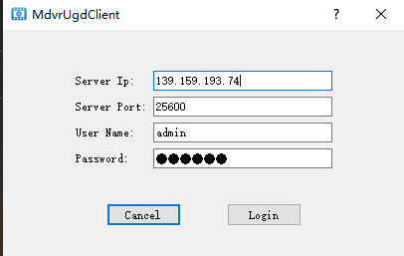
You can see the list of products on the left side of the login. After selecting the specified product, you can see the product description and version list on the right.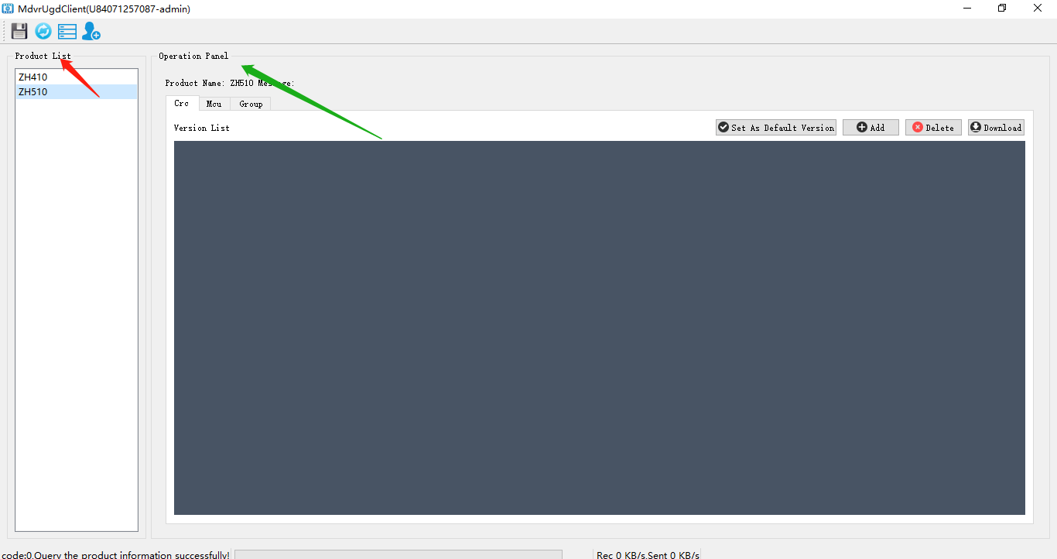
Remote Upgrade You can upgrade the application (App) and MCU (MCU). Remote Upgrade Management Sets in the Device Remote Upgrade Settings interface, the remote download file is configured in the parameter configuration interface, configuring the upgrade mode in each configuration interface, can be Specify version upgrade or use the default version to upgrade.

User and product add and delete
The administrator logs in to the client to add a product, add the user, and the operation that can be performed by ordinary users.Clickbutton for product addition and user management.
Add products and users to the Product and User interfaces, adding the product in the Product interface, the name of the product must be the same as the software package main board type, otherwise it is not possible to add the corresponding version of the software for the corresponding product, and it can also be selected to delete it;
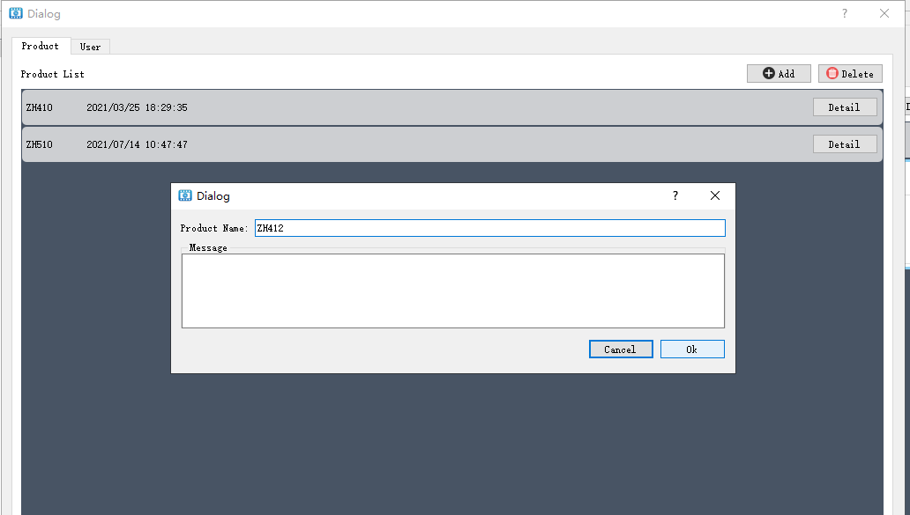
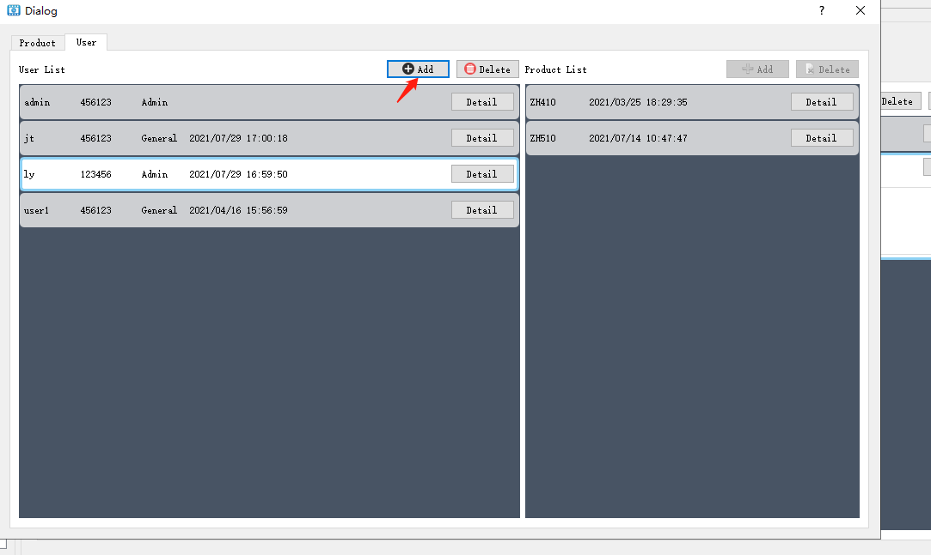

Add users to the User interface. Select a user, you can add or delete the product for the productlist.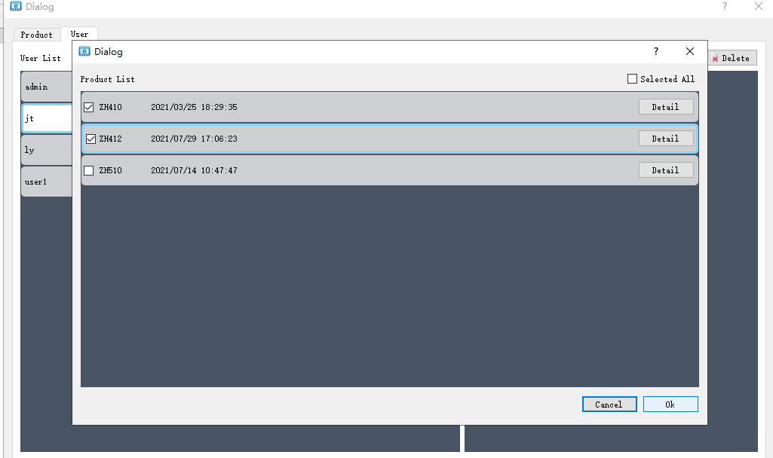

APP Upgrade

PC operation
APP upgrade package file name format: DVR- version number (9 characters) - motherboard number. SVN number - language .crc
eg：DVR-T21011165-ZH410.5051-CH.crc
Can have the following operations：
- Clickupload new version。
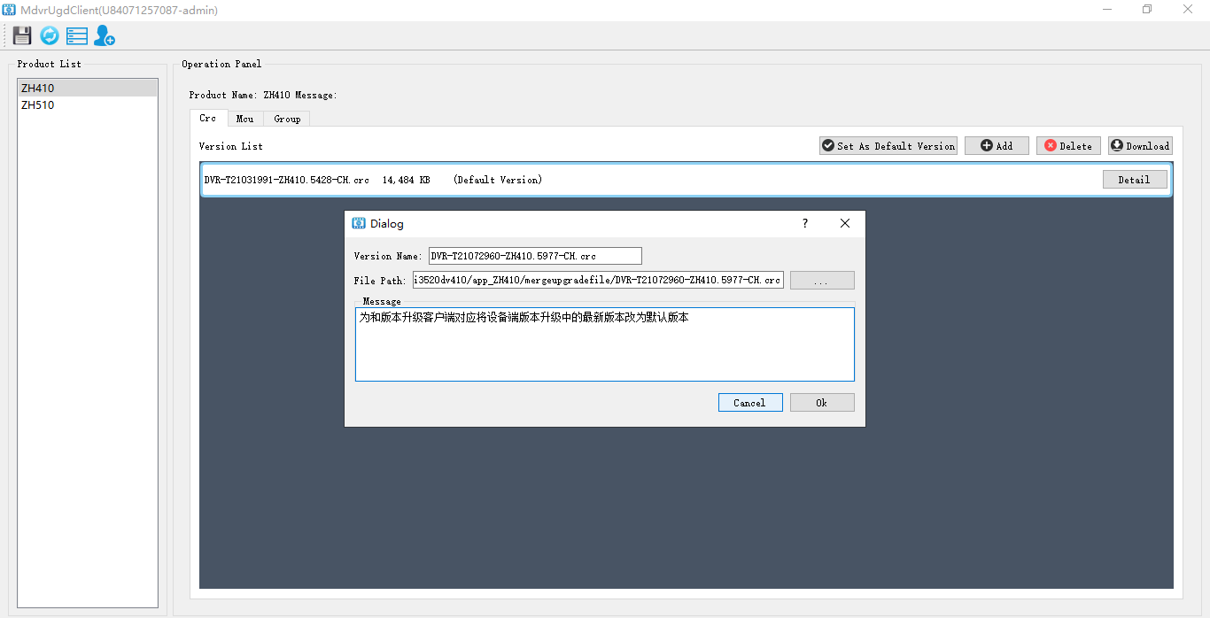
Determine the local file to the server after you want to upload the version file, and display the uploads as shown in the figure:
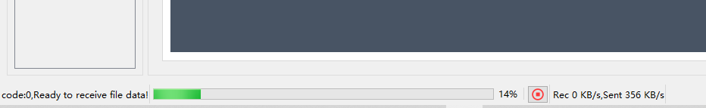
- Clickdelete selected version
- Clickdownload the selected version, download the files on the server to the local.
- Click set the selected version as the default upgrade version. The is the default version in the version list. A model can only set a version of the default App version. This version will be upgraded when you select "Default Version" on your device.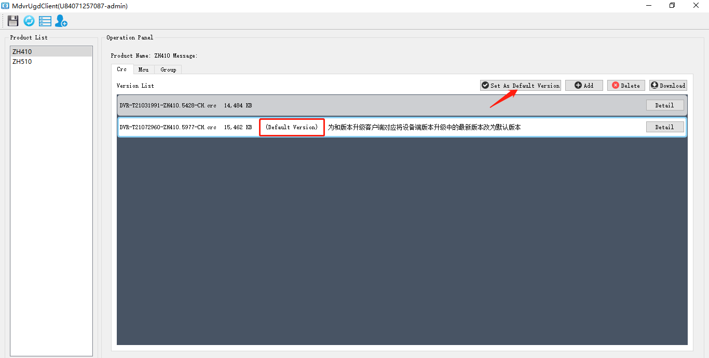
- ClickView the version of the selected version details.
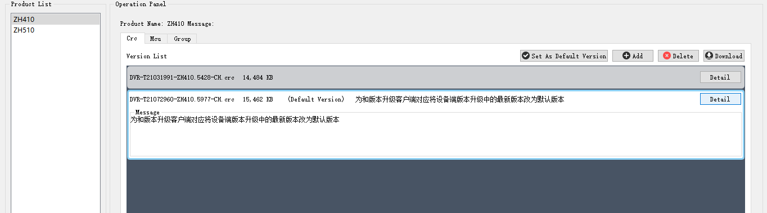

Device operation

Upgrade configuration
Enter the version management interface Set the server IP, port.

Romote Upgrade:
- ”Default” or “Newest”:（Corresponding to the version list words in the version list on the PC);
- ”Specify”: Required by entering the version of the version of the app upgrade package file name file name must be on the list of PC.

Auto Update：
- ON：Take it once when booting, automatically detect an upgrade every 30 minutes after booting
- OFF：4. Click the "Update" button to upgrade

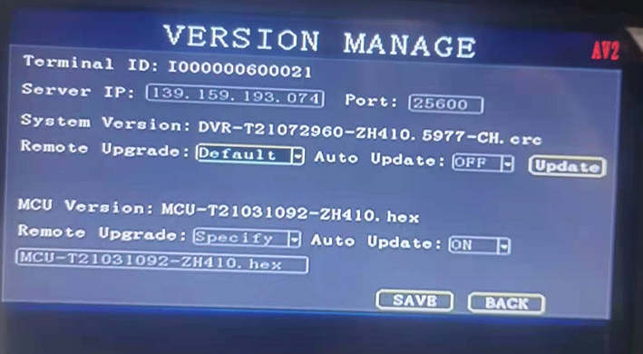

Connect the server and detect the corresponding upgrade file to download the server's upgrade file to the device's memory in the memory, display the file download progress in the monitor interface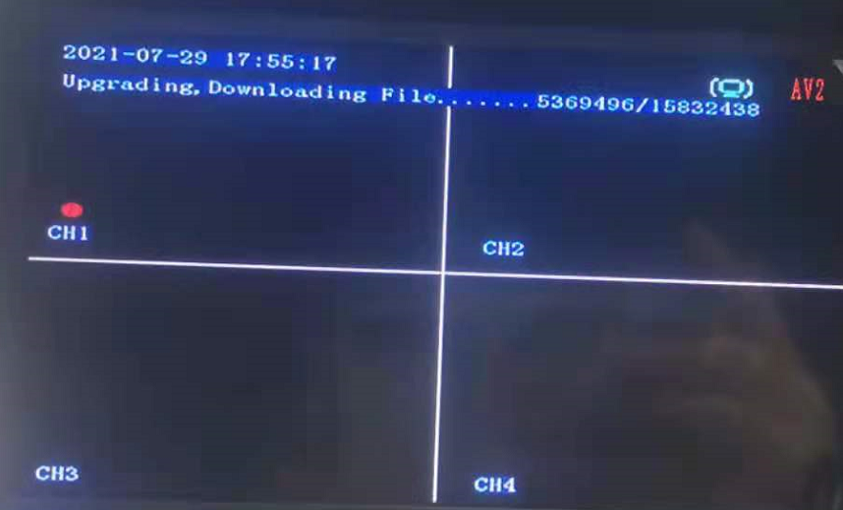

MCU Upgrade
For MCU upgrade package, file name format: MCU model (3 characters) - version number (9 characters) - motherboard number .hex
eg：MCU-T20072391-ZH410.hex or F03-T21010932-ZH410.hex
Increase the specified, different MCU types of the MCU type, you can specify a default version。
Operation and App upgrade, refer to the APP upgrade
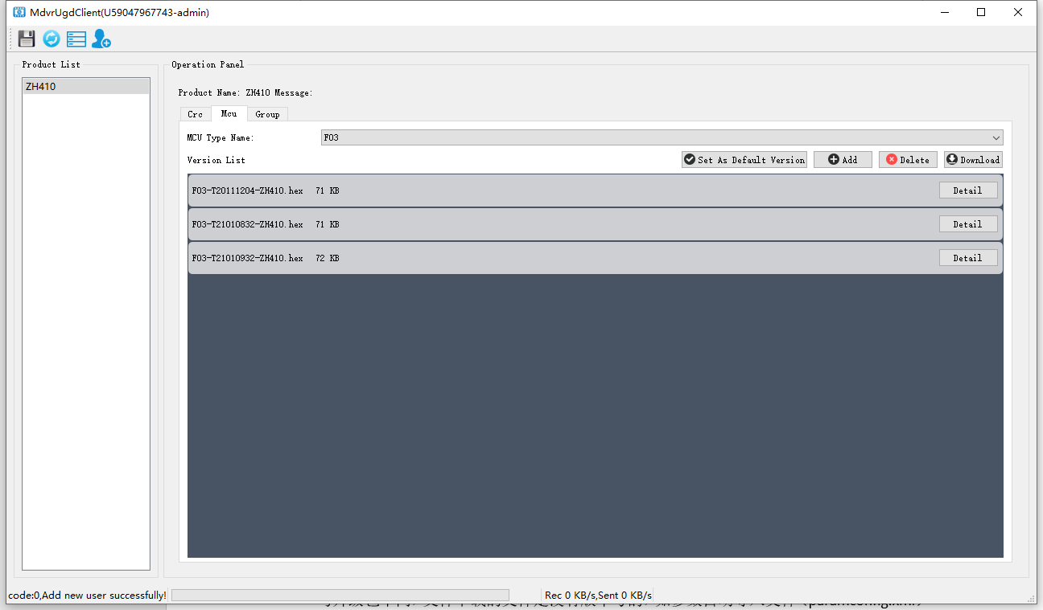

File upload download function

File upload, device upgrade
Upload the files of some devices can be transmitted to the server on some devices, and then download them to the PC as needed.
Operation: On the page upload page, you can add a device (string within 20 characters), form a list of devices, after selecting a device, you can add the files that you need to upload this device, you can add multiple, but you need a full path Such as /mnt/nand/debug.log and /mnt/nand/debug.log.bak. After adding a list of files, and is in the [Started Upload] state. After the device and server communicate, detect your device number in the server's file upload device list, get the list of files that you need to upload and upload one by one. Note that when matching the device, you can match the device number, mobile phone number, video ID, and license plate number, and one of the matches is successful. Uploaded files display [Upload] Status, after uploading, display [uploaded] status, at this time, the PC client can click on the download file. To avoid a mobile phone number, the file name uploaded by the two devices, the file name is uploaded, and the device number is added before the file name (the device number is unique number not repeated) and the upload start time. If the mobile phone number of the two devices is filled, their device number is 100021 and 100082, respectively. Then they upload /mnt/nand/debug.log, the uploaded file name is 1000021_20210311-092501_Debug.log and 100082_20210311-092501_debug.log.
Clickbutton Add event, the interface is shown below:
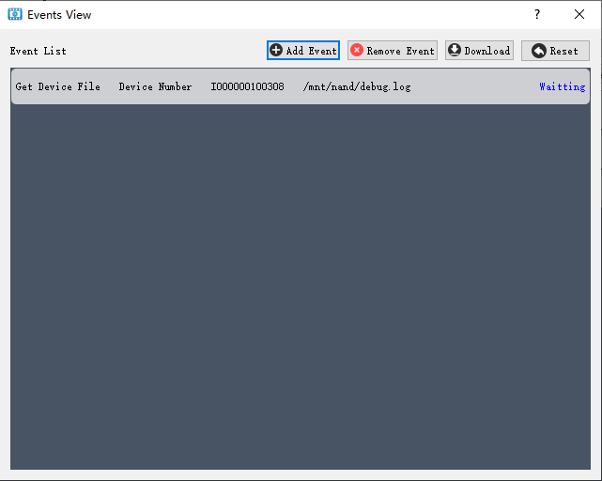
Click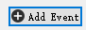add events, the interface is shown below:
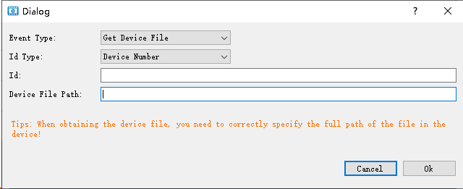
After adding each parameter, click OK to complete the event addition. After the event is detected on the device side, the execution result of the corresponding event will be fed back to the server.
The event types include: obtaining device files, upgrading CRC files, upgrading MCUs, and upgrading combined files; during the upgrade operation, if the version is not specified, the default version will be upgraded, and if the version is specified, the upgrade will be performed according to the specified version.Among them, 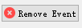remove events; 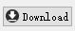download the device upload to the server's document, when the event status changes to succeed, can download files from the server; re-execute the event.

file download
Unlike the upgrade package, the file download file is not version number, corresponding to the file group name, such as the parameter automatic import file (paramconfig.xml) and the bootingupgrade.jpg). Set the parameter configuration interface in the device.
Action: You can build a version number first in the file download page, form a version list, after selecting a version number, you can add upload different files to this version number. After the device is connected to the server, download all the files in this version number to the device temporary directory after the server is downloaded. After the download is complete, copy it to / mnt / Nand once again, and perform the restart action.

The device-side download file is downloaded in the form of a file group, and the interface is shown below.
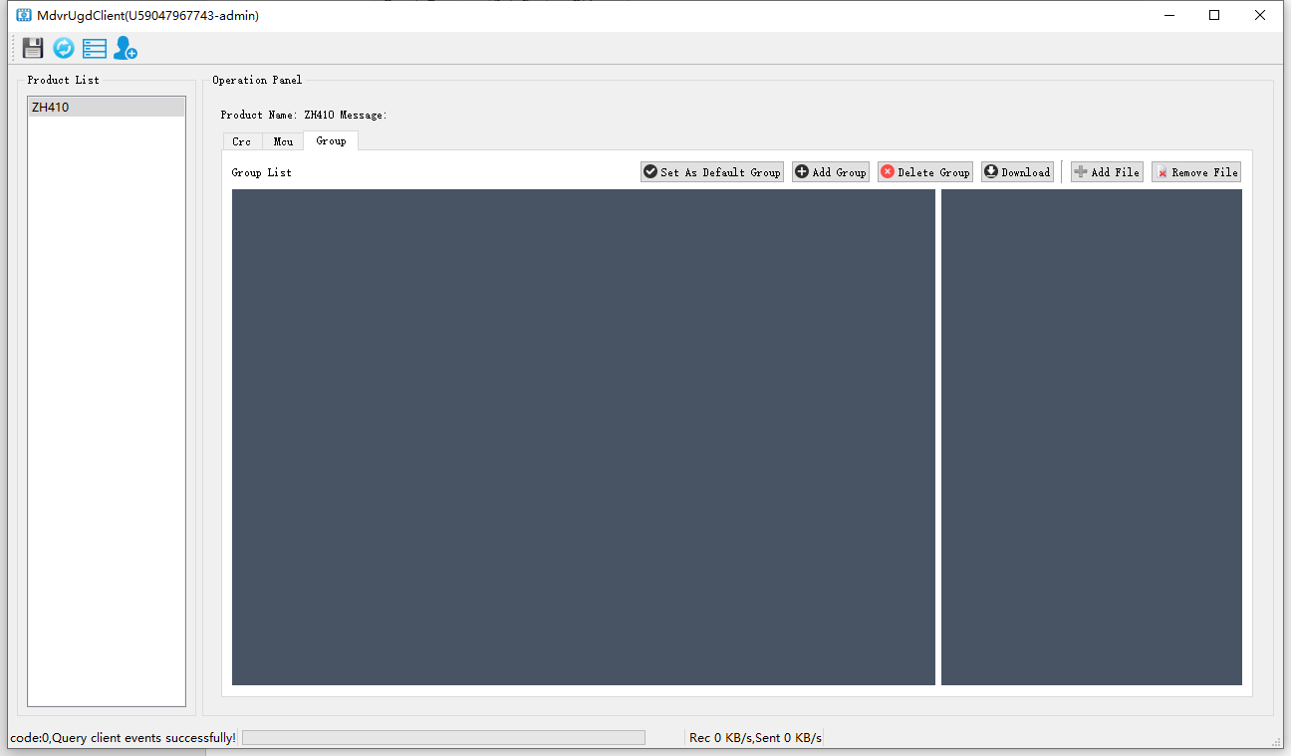
Where set the current product default download file group, add file groups, delete file groups, download the currently selected file from the server to local, add files to the current file group, delete the current file group selected

Log query operation
The log query function can search the device module status log and upgrade log, and can search according to different product names, device numbers, IMEI numbers, log status, and log types
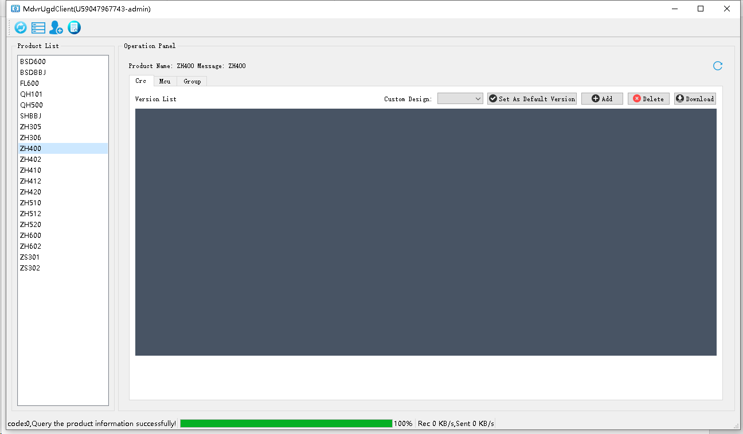
Click the button to enter the log search interface:
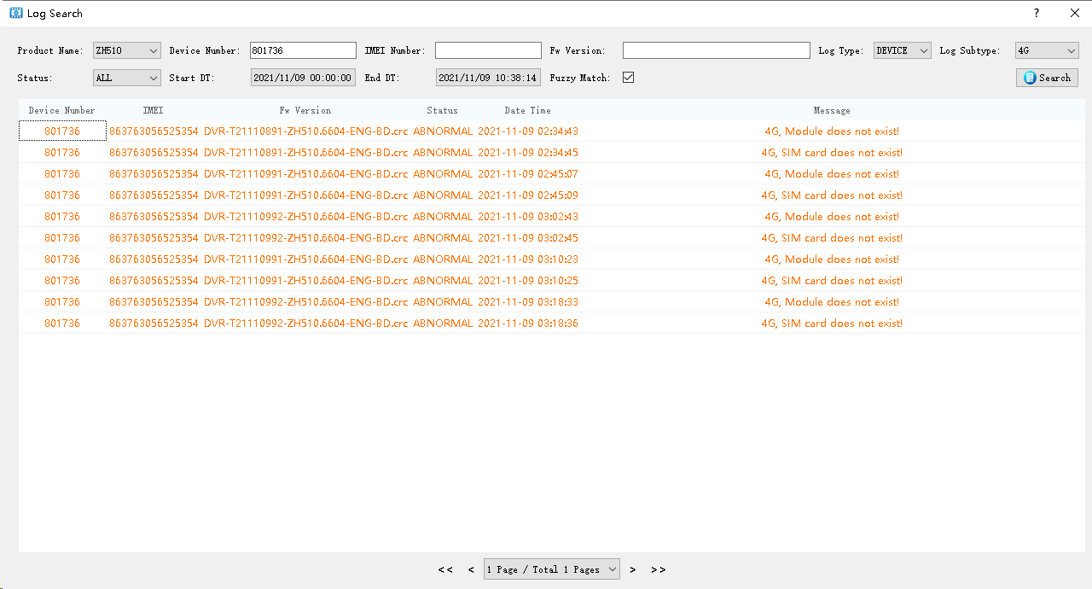
Search according to different conditions in the log search interface. The search conditions can support fuzzy matching and complete matching.

